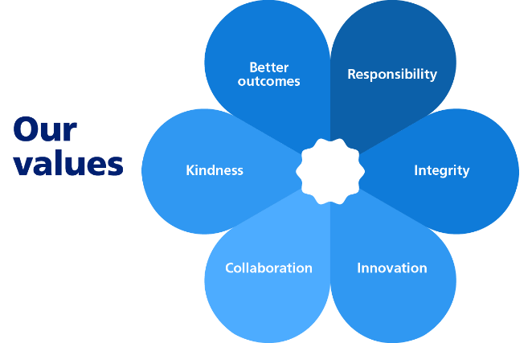
 

JOB TITLE: Principal Urban Designer
SALARY: Local Grade 9 (£48,766- £53,610) (37 hours per week, Mon-Fri)

What is the role?

The Urban Designer will work across the Council, and the Planning Service in particular, to provide specialist advice on urban design in conjunction with new developments in the Borough.

The postholder will assist with planning policy preparation, preparing masterplans and guidance for applicants and playing a key role in discussions with site promoters on how sites may be brought forward. This work will contribute to the preparation of the Council’s new Fareham Local Plan 2044.

The role will advise on major and other significant planning applications and pre-application planning enquiries, and the post holder will be expected to have an in-depth knowledge of national design guidance and practice.

The postholder will also work across services as a corporate urban design resource working on priority projects such as business parks at Daedalus, sites and projects on behalf of Fareham Housing and corporate Leisure and Community proposals.

You will work to ensure appropriately detailed considerations are given to projects in order to meet the objectives of the adopted and emerging Local Plan, and also the Corporate Strategy and Corporate Strategy and associated Corporate Priorities and key projects.

Whilst there are no line management requirements of this role, you will be expected to work with more junior Officers to help them build a broader knowledge of urban design issues in practice.

Key areas of work will be:
- Preparing concepts, masterplans and development briefs for specific development proposals within the Borough, whether they will be delivered by third parties or the Council
- Providing timely and sufficiently detailed urban design advice to others, including on complex matters
- Liaising with colleagues in the Planning Strategy and Development Management teams within the Planning Service and also the Asset Management, Fareham Housing and the Leisure and Community Services on development proposals and positively representing the Council at meetings with external parties.
- Attending site visits with clients, contractors or to undertake design work
- Keeping up to date with national and local planning policies and design guidance, to ensure that the appropriate outputs and outcomes are delivered.
- Understanding the Corporate Strategy and associated Corporate Priorities and key projects and help to develop appropriate responses to these within your area of expertise.
Who is the person?
It is important to us that:
You are a qualified urban designer and have considerable experience in a relevant role at a senior level. You will be skilled in graphic illustration, including digital formats such as AutoCAD.

You have demonstrable experience in providing urban design advice.

You have a detailed understanding and knowledge of the legislation, procedures and guidance relating to planning policy matters.

You display sound decision-making skills and can identify and analyse issues, identify alternative courses of action and take risk-based decisions with the minimum of supervision.

You are an effective negotiator.

You have excellent verbal and written communication skills and are able to deal with customers and colleagues in a helpful and polite manner.

You have good IT skills and are proficient in the use of a variety of programmes.

You have a ‘can-do’ attitude with the determination and drive to see projects through to a successful conclusion.

You are able to adapt to change positively, and pro-actively seek suitable solutions dealing with challenging planning and development issues.

You have a full driving licence and access to a car to travel to external meetings and conduct site visits.

You are able to attend occasional evening meetings.

Our policy is to make adaptations for those who have substantial and long-term disabilities. If you need an adaptation to carry out any of the above please let us know.
July 2026

